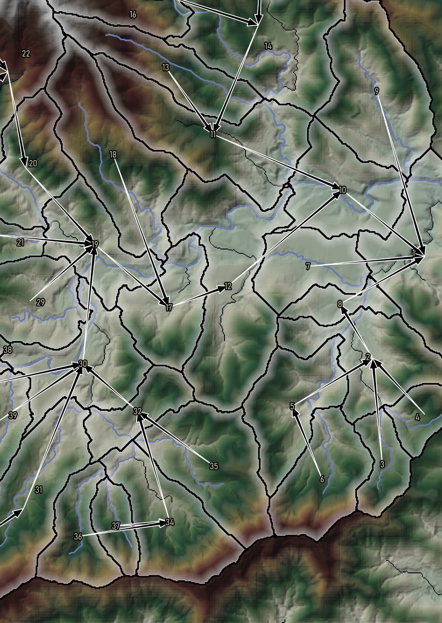

QMydro User Manual

Callan Schonrock, 2024

# Table of Contents

Table of Contents ii

1 Introduction 1

2 QMydro Installation 1

3 How it Works 3

4 Inputs 3

5 Outputs 4

6 Recrunch Feature 4

7 Running QMydro Standalone 5

8 Errors/Warnings 6

# Introduction

This user manual serves as documentation for the software package QMydro. The QMydro software package consists of the QMydro catchment processing software and the QGIS plugin interface. QMydro facilitates hydrologic model file development, supporting URBS, RORB and Mydro.

# QMydro Installation

The QMydro package downloadable from HydroRepo.com consists of the “QMydro.zip” file for QGIS plugin installable from the QGIS plugin manager **“Install from ZIP”** as shown in Figure 1. After installation it will appear in the toolbar ribbons of the QGIS instance (Figure 2).

As shown in Figure 3, the QMydro QGIS interface can be used to specify input files for QMydro, **an external command prompt will be called in a new tab** for computational analysis when QMydro is executed. **QGIS will wait for QMydro execution to exit** and will not respond to user input while the batch file is open. On first execution, a license key will be required to be entered, obtained from a HydroRepo subscription, subsequent runs will access the cached license key file, and complete the processing. It is recommended that all specified files be within the same **local** coordinate reference system (CRS).

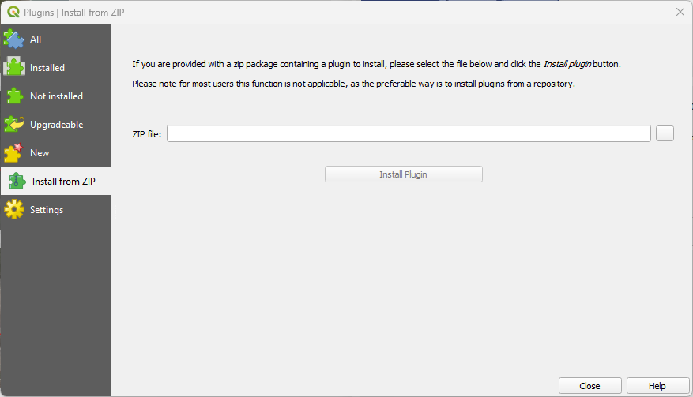

Figure 1: QMydro QGIS Installation

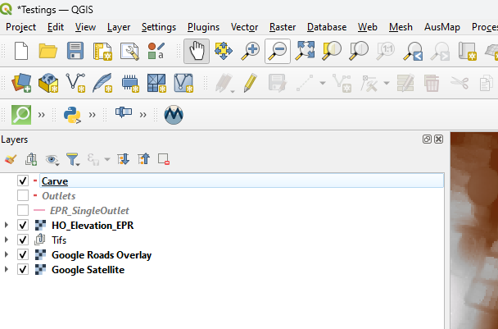

Figure 2: QMydro Toolbar Location

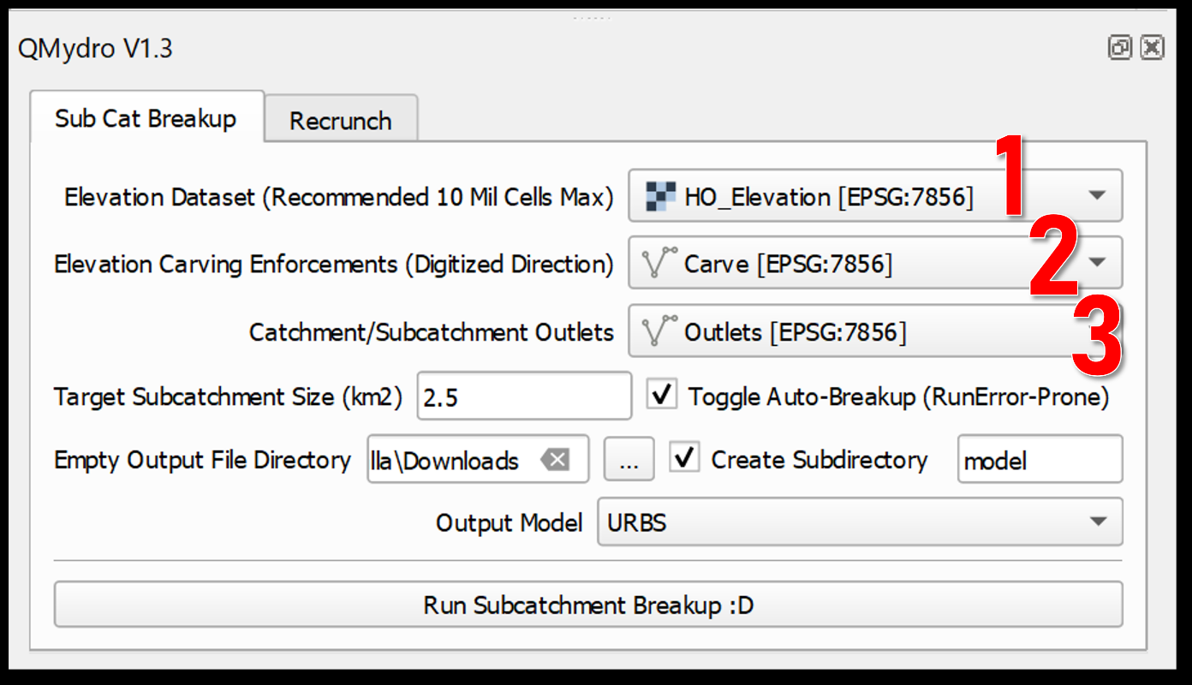

Figure 3: QMydro Plugin Usage

# How it Works

QMydro employs the D8 algorithm to determine drainage direction. One notable drawback of the D8 algorithm is the “Snapping” of flow direction to a maximum of 22.5º. Alternative methods like that proposed of CatchmentSIM use a modification of Lea’s (1992) algorithm, where the drainage direction is defined as a vector where direction is defined from gradient. While this method can yield more precise results for flow path length and slope, the additional precision did not warrant the computational effort.

Both channel and catchment slopes are estimated from the Equal Area slope, where no substantial slope is determined, a minimum of 0.0005m/m is adopted.

# Inputs

QMydro has several mandatory and optional inputs, which are recommended to be in the same local projections including, differing projections will throw a warning. Notably temporay/scratch files are not supported by QMydro, ellipsoidal projections (WGS84) are not currently supported, please use local CRS:

* Elevation Raster (MANDATORY)
  + Catchment Elevation DEM.
  + GDAL Compatible formats.
  + Cloud Optimized Formats not supported.
* Carving Vector (OPTIONAL)
  + Vector layer (Line Shapefile).
  + Carves elevation from source DEM for hydraulic enforcement of Dams Embankments, Roads etc. Elevation enforcement is undertaken from start to end (digitized direction).
* Outlets (MANDATORY)
  + Vector layer (Line Shapefile).
  + Defines a catchment/subcatchment outlet, drawn over the cross section of the waterway at the outlet location.
  + Multiple final outlets supported as well as self-contained outlets.
  + The line feature drawn, will pick up “outlet” cells containing significant contributing upstream area. It is best drawn in a well defined channel
* Target Subcatchment Size (OPTIONAL)
  + Automatic breakup target subcatchment size, aimed to breakup at large stream branching.
* Empty Output File Directory
  + It is recommended that this be an empty output directory only containing superseded QMydro results to be overwritten.
* Output Model
  + Currently Supporting Mydro, URBS, RORB, and WBNM input files.

# Outputs

QMydro outputs several files that can be used for hydrological analysis including:

* Accumulation Raster
* Subcatchment Polygons
  + Subcatchment ID, Area, Upstream Area, Main Stream Length, Time of Concentration (Bransby Williams)
* Subcatchment Nodal Links
  + Centroid to Centroid
* Main Stream Path Vectors
* Mydro/URBS/RORB/WBNM Build Files

# Recrunch Feature

Recrunch is a feature, that does not require a HydroRepo license key, allowing manual editing/creation of subcatchment shapefiles for hydrologic models. This is a free alternative for users without a license, it does not calculate areas, stream slopes, nodal links or any other subcatchment characteristics, it merely uses the attributes in subcatchment shapefiles to generate hydrologic subcatchment model files for URBS, WBNM and RORB. Required fields in each layer are detailed on selection of target hydrologic model and as below:

* Mydro
* Subcatchments-

Required: ID {Subcatchment ID (Numeric)}, Area {Numeric}, HS {Hill Slope m/m}, HL {Characteristic/Average Hill Length km}, B {Lag parameter Beta ~1.0}, m {Lag Parameter m ~1.0}, I {Fraction Impervious 0.0-1.0}, DS {Downstream subcatchment, -1 or 0 for final subcatchments}

* Streams-

Required: ID {Associated Subcatchment ID}, Length {Main Stream Length in Kilometres}, Slope {Slope (m/m) 0.0-0.1}

* URBS
* Subcatchments-

Required: ID {Subcatchment ID (Numeric)}, Area {Numeric}, CS {Equal Area Catchment Slope m/m}, I {Fraction Impervious 0.0-1.0}, DS {Downstream subcatchment, -1 or 0 for final subcatchments}

Optional: U {Fraction Highly Urban 0.0-1.0}, F {Fraction Forested}

* Streams-

Required: ID {Associated Subcatchment ID}, Length {Main Stream Length in Kilometres}, Slope {Slope (m/m) 0.0-0.1}

* RORB
* Subcatchments-

Required: ID {Subcatchment ID (Numeric)}, Area {Numeric}, I {Fraction Impervious 0.0-1.0}, DS {Downstream subcatchment, -1 or 0 for final subcatchments}

* Streams-

Required: ID {Associated Subcatchment ID}, Length {Main Stream Length in Kilometres}, Slope {Slope (m/m) 0.0-0.1}

* WBNM
* Subcatchments-

Required: ID {Subcatchment ID (Numeric)}, Area {Numeric}, I {Fraction Impervious 0.0-1.0}, DS {Downstream subcatchment, -1 or 0 for final subcatchments}

# Running QMydro Standalone

The QMydro Plugin is essentially solely calling a template batch file to run the QMydro executable file. On installing QGIS the QMydro executable is downloaded within the QGIS plugin directory, which can be found from:

QGIS -> Settings -> User Profiles -> Open Active Profile Folder

Python -> Plugins -> QMydro -> scripts -> CS -> delineateCatch.exe

After locating delineateCatch.exe in your system, QMydro can be executed through a batch file similar to that shown in Figure 4, a template batch file is located in the same directory as the executable, do not edit this template batch file, as it is used for the QGIS interface.

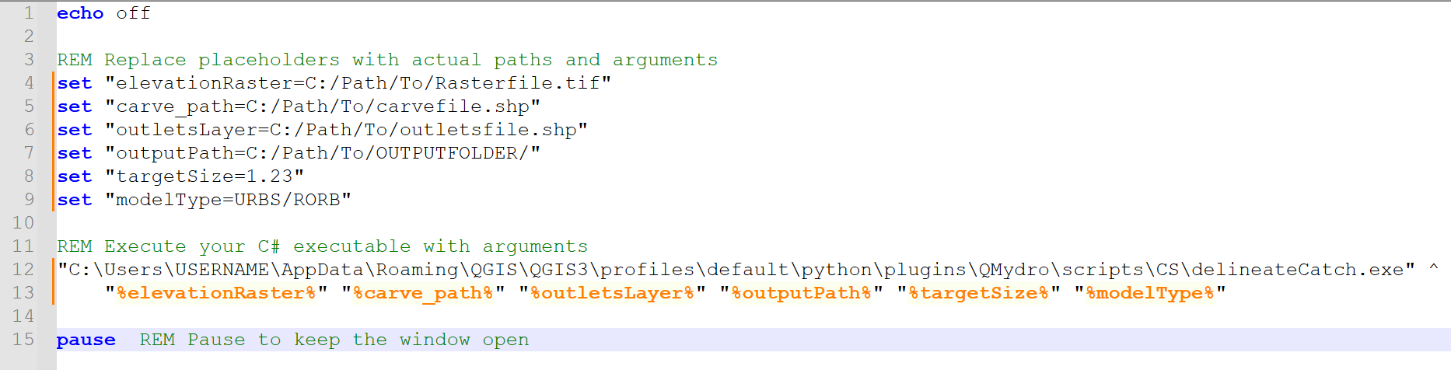

Figure 4: Standalone QMydro Executable

# Errors/Warnings

*"WARNING: XXX Projection does not match XXX/Unknown projection”*

Some CRS of layers may not be explicitly defined in the layer, or may not be able to be read by QMydro. If the CRS is not defined, but CRS is consistent between all layers, the script should work as normal. If this persists, try “Warp”/”Reproject” into the local projection again.

*“There was an error verifying the license key: {Details}”*

Please check connection, and connection to hydrorepo.com. Please contact [callansch@gmail.com](mailto:callansch@gmail.com) immediately with a screenshot of the error to inform us to further investigate.

*"Error: Input file {filePath} does not exist. File may be created from a scratch / memory / temporary layer"*

Ensure that the file is a regular shapefile, and not a scratch layer. If the layer was saved to a shapefile from a scratch layer, this issue may persist. Please try create a new shapefile and copy features from the old layer.

*"Error initializing GDAL: {ex.Message}"*

GDAL binaries are missing / incompatible with system, please try redownloading the zipfile from hydrorepo.com. Contact [callansch@gmail.com](mailto:callansch@gmail.com) if issue persists.

*"ERROR DETERMINING UPSTREAM / DOWNSTREAM SUBCATCHMENTS"*

Likely an issue with outlets layer, crossing outlets, or problems with auto breakup crossing manual sub-outlets. Try turning off auto-breakup in instances where you have digitized several manual outlets. Check routing file for where the script got up to before failing.

*"ERROR WITH OUTLET AT CELL X: Y: "*

Check outlets, X, Y give raster coordinates of the outlet causing issues.

*"INVALID MODEL: {model}, Use URBS, or MYDRO scripts to convert URBS to RORB and WBNM are available in model package"*

Currently QMydro calculates URBS/Mydro directly, and then translates into RORB/WBNM. Please specify URBS to then translate into WBNM/RORB using convertToRORB.py or convertToWBNM.py